Instruction of time control panel for XBOX interface

I、General Function instruction
THE control interface for XBOX console。It is a time control for a large game console whose game resources on the hard disk provided by the XBOX game player through the process of copy. It supports joystick control, coin-operated time set, single/two players control, AV output, RGB output and volume adjusting.

II、Specific Description of each function
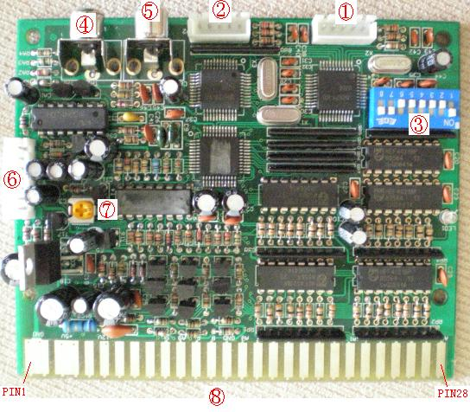
1. One PLAYER (hereinafter referred to as the 1P) for XBOX line port, link this port with XBOX console controller Port one
2. One PLAYER (hereinafter referred to as the 1P) for XBOX line port, link this port with XBOX console controller Port two
3. time set by every coin in and special function option switch (See Appendix 2:option set and function instruction for details.)
4. Video output, linked with the yellow video input port on the TV.
5. Audio output, linked with the red or white input port on the TV.
6. Main signal(video and audio) input of the host game player.
7. Reset control output port on the controller
8. Volume output on golden touch, adjusting the volume
9. The golden touch faucet on the linker, linked with big joystick drop-out line
(See the Appendix3: linker port instruction for details about the function of the golden touch pin on the linker.)

III. Operation instruction
1. Whenever you link all the ports correctly according to the instruction above, the television screen will show XBOX game program menu interface and the phrases “INSERT COIN”“1P 00：00“2P 00：00”will appear on the screen to remind you to insert game currency to obtain game time.
2. when you use up your game time, the time bar will be 1P 00：00 2P 00：00 and the phase “TIME OUT CONTINUE 9 8 7…`…0”will appear on the screen to ask you whether to insert game currency to continue the game or not. If you insert a game currency at once, you’ll get game time
and the phase will disappear.

2. “1P”， “2P”，refer to the joysticks for user 1 and for user 2 separately.

Appendix 3：CONNECT instruction for every pin
XBOX BUTTON  1P |  | Top surface  1P | Button Surface  2P | XBOX BUTTON  2P
Game Pad button | Interface PIN | PIN | PIN | Game Pad button | Interface PIN
LT1 | 1P KEY7 | 28 | 28 | 2P KEY7 | LT1
White | 1P KEY6 | 27 | 27 | 2P KEY6 | White
Black | 1P KEY5 | 26 | 26 | 2P KEY5 | Black
Y | 1P KEY4 | 25 | 25 | 2P KEY4 | Y
X | 1P KEY3 | 24 | 24 | 2P KEY3 | X
B | 1P KEY2 | 23 | 23 | 2P KEY2 | B
A | 1P KEY1 | 22 | 22 | 2P KEY1 | A
RIGHT | 1P RIGHT | 21 | 21 | 2P RIGHT | RIGHT
LEFT | 1P LEFT | 20 | 20 | 2P LEFT | LEFT
DOWN | 1P DOWN | 19 | 19 | 2P DOWN | DOWN
UP | 1P UP | 18 | 18 | 2P UP | UP
START | 1P START | 17 | 17 | 2P START | START
 | 1P COIN | 16 | 16 | 2P COIN
RT1 | 1P KEY8 | 15 | 15 | 2P KEY8 | RT1
 | VIDEO GND | 14 | 14 | MENU KEY
 | BLUE | 13 | 13 | SYN
 | RED | 12 | 12 | GREEN
BACK | 1P KEY9 | 11 | 11 | 2P KEY9 | BACK
 | SPEAKER | 10 | 10 | SPEAKER
 |  | 9 | 9
 |  | 8 | 8
 |  | 7 | 7
 | +12V | 6 | 6 | +12V
 |  | 5 | 5
 | GND | 2 | 2 | GND
 | GND | 1 | 1 | GND

Appendix 2: Option setting and function instruction
- the game time per coin can be set by adjusting the of SW1-SW5 1-30mins/cion
分钟/币  Minute/coin | SWICH 1 - 5
分钟/币  Minute/coin | SW1 | SW2 | SW3 | SW4 | SW5
测试模式  Test model | OFF | OFF | OFF | OFF | OFF
1 Minute | ON | OFF | OFF | OFF | OFF
2 Minute | OFF | ON | OFF | OFF | OFF
3 Minute | ON | ON | OFF | OFF | OFF
4 Minute | OFF | OFF | ON | OFF | OFF
5 Minute | ON | OFF | ON | OFF | OFF
6 Minute | OFF | ON | ON | OFF | OFF
7 Minute | ON | ON | ON | OFF | OFF
8 Minute | OFF | OFF | OFF | ON | OFF
9 Minute | ON | OFF | OFF | ON | OFF
10 Minute | OFF | ON | OFF | ON | OFF
11 Minute | ON | ON | OFF | ON | OFF
12 Minute | OFF | OFF | ON | ON | OFF
13 Minute | ON | OFF | ON | ON | OFF
14 Minute | OFF | ON | ON | ON | OFF
15 Minute | ON | ON | ON | ON | OFF
16 Minute | OFF | OFF | OFF | OFF | ON
17 Minute | ON | OFF | OFF | OFF | ON
18 Minute | OFF | ON | OFF | OFF | ON
19 Minute | ON | ON | OFF | OFF | ON
20 Minute | OFF | OFF | ON | OFF | ON
21 Minute | ON | OFF | ON | OFF | ON
22 Minute | OFF | ON | ON | OFF | ON
23 Minute | ON | ON | ON | OFF | ON
24 Minute | OFF | OFF | OFF | ON | ON
25 Minute | ON | OFF | OFF | ON | ON
26 Minute | OFF | ON | OFF | ON | ON
27 Minute | ON | ON | OFF | ON | ON
28 Minute | OFF | OFF | ON | ON | ON
29 Minute | ON | OFF | ON | ON | ON
30 Minute | OFF | ON | ON | ON | ON
FREE | ON | ON | ON | ON | ON

b. SW6—SW8 Specific function of SW6—SW8
SW6 slot number option switch
SW6=ON If two users insert coins to the same slot, do as the followings: after a user insert
a coin to the slot, there will be a yellow number1-9 between the time bars of 1P and 2P on the screen. When 1p press START and hold 1S, the time bar of 1P will show the time which SW1-SW5 set. When 2P press START and hold 1S, the time bar of 2P will show the time set by SW1-SW5 .
SW6=OFF When two users inset coins to two separate slots, do as followings: when 1P insert
a coin to slot 1, the time bar of 1P will show the time set by SW1-SW5.(If the time bar of 2P shows the same time as 1P’s, please see SW8 setting instruction for details. )

SW7 back to menu setting switch
SW7=ON When the time bars of 1P and 2P show “time out 9 8 7 …… 0”,XBOX host player will
reset console.
SW7=OFF When the time bars of 1P and 2P show “time out 9 8 7 …… 0”,XBOX host player won’t
reset console.

SW8 1P and 2P increment time when coin in switch setting
SW8=ON when a user inserts coin to slot 1P,the time bar of 1p will show a relevant time set by SW1-SW5.
when a user inserts coin to slot 2P,the time bar of 2p will show a relevant time set by SW1-SW5.
SW8=OFF When a user insert coin to the slot, the time bars of 1P and 2P will show the same relevant time set by SW1-SW5.
Note: This model works only when SW6=OFF.
IV、connection mode
Please link XBOX Console, controller interface, game player display/monitor as the following photo shows.
a.70000 PS console and PS interface，game hard disk，memory card，connect 。
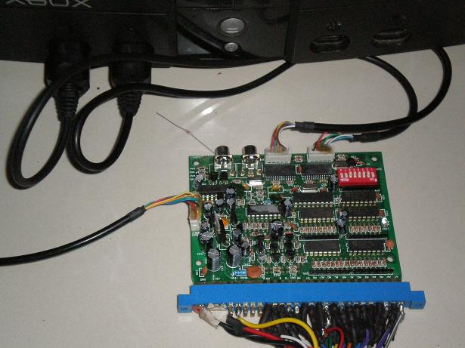
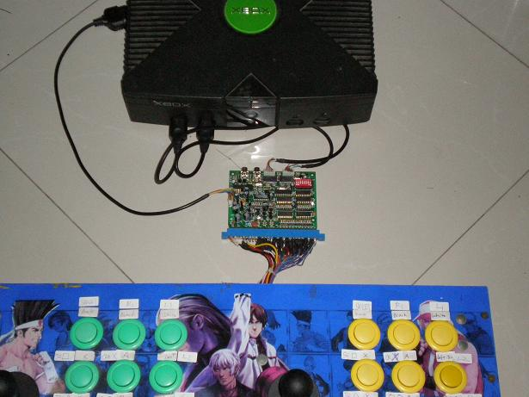

V、common questions and solutions
（略）

